Location Manager/ Area Manager/ GM Home Page

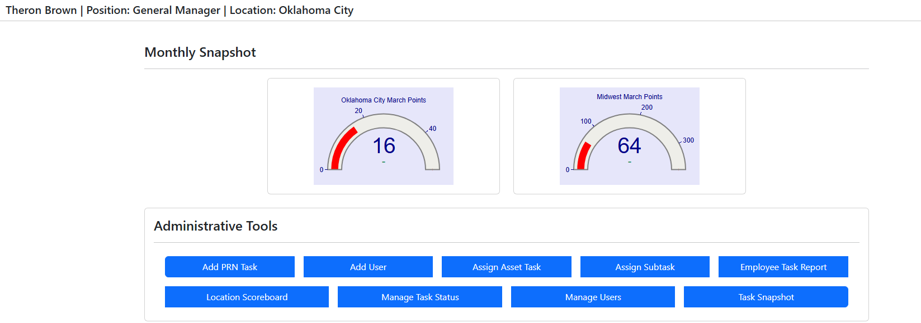

Creating & Assigning a PRN (Work Order)
ADD PRN Task:
- This is where the manager will create PRN (AKA Work Orders/ Tasks). Enter in the details such as Task Name, Expected Completion Date, Assigned User, etc. Pictures can also be added as well.
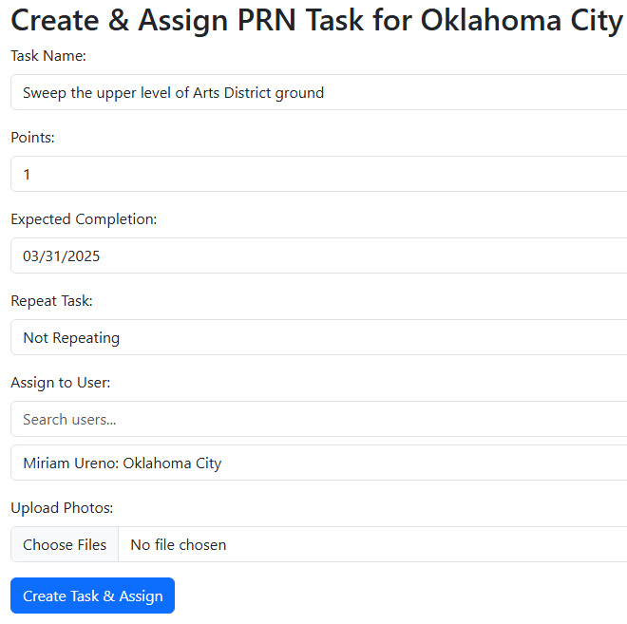

- The PRN will now be visible to the end-user (Field User) on their login. Once the PRN is created and assigned, it will be visible to the end-user as follows:
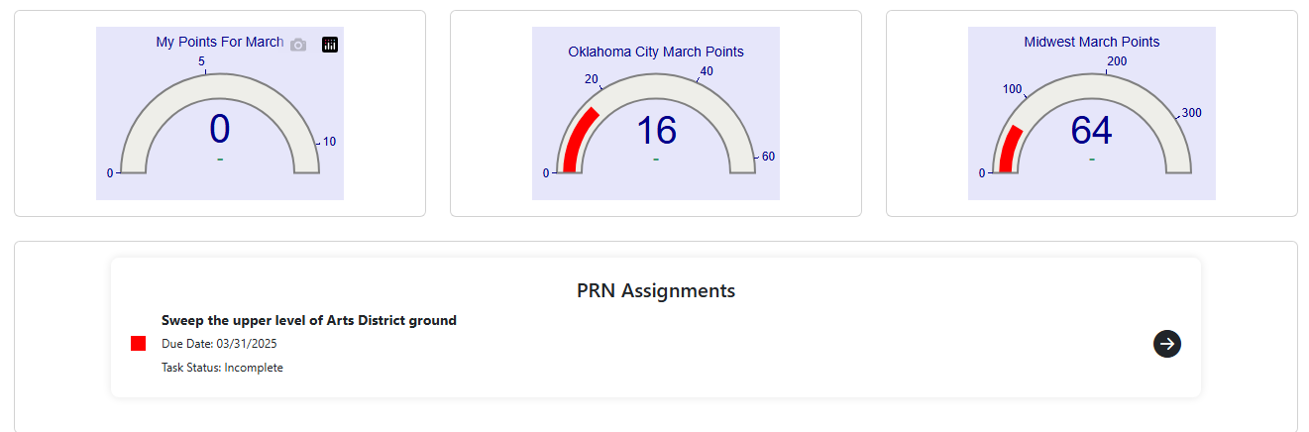

- Viewing & Closing PRN: the end-user will view PRN’s in the top field of their home page, above their daily, weekly and monthly tasks fields. PRN’s that have no reoccurrence designation, will appear at the top of the end-users home page as those take priority over their routine daily, weekly, and monthly duties.
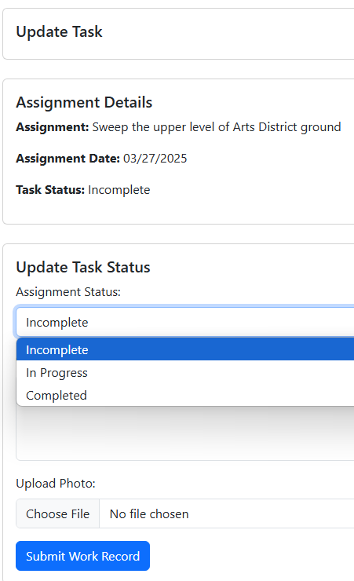
Creating a work order or recurring task for a piece of equipment, such as vehicle, PIL, etc. maintenance
- To create a PRN for a vehicle, click the Assign Asset Task option on the manager main page. The screen setup will look similar to a regular PRN, only here you will be able to set up tasks such as oil change, tire rotation, etc.
- Fill out the required fields such as Task Name, Asset, Task Description, etc. Once completed, click ‘Create Task & Assign’.
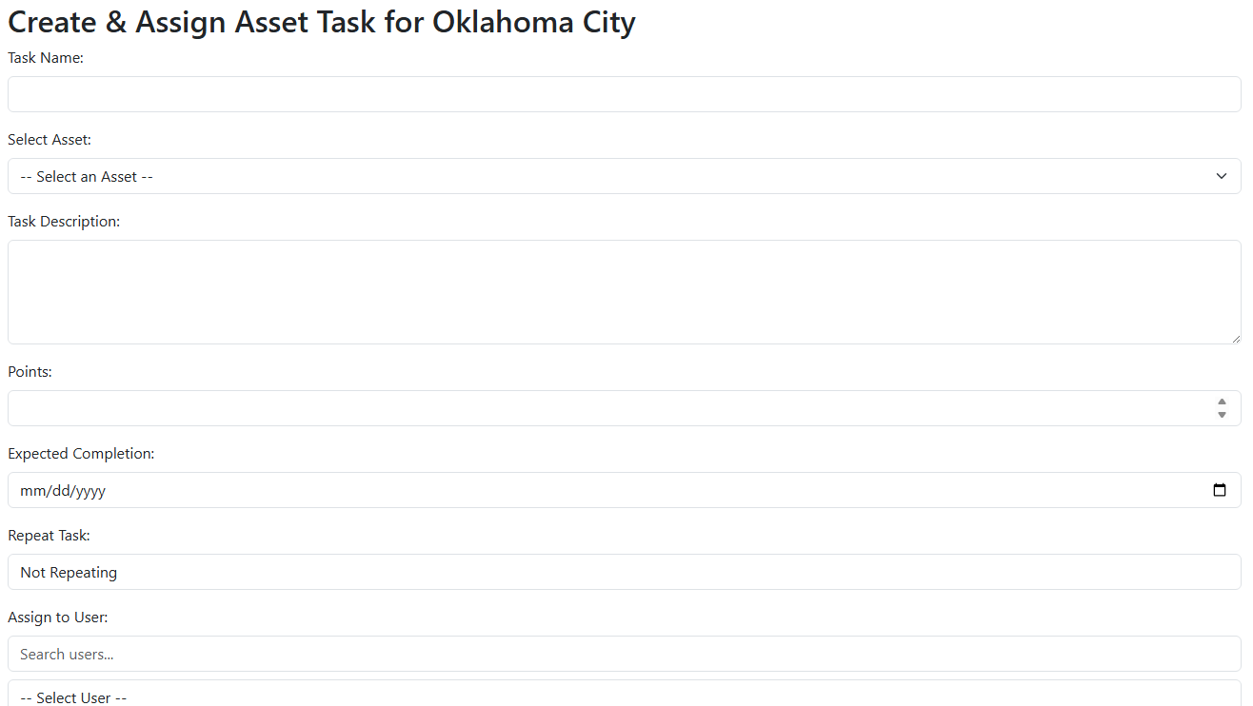
- Once the asset PRN is created, see below how it appears to the assigned field-user.
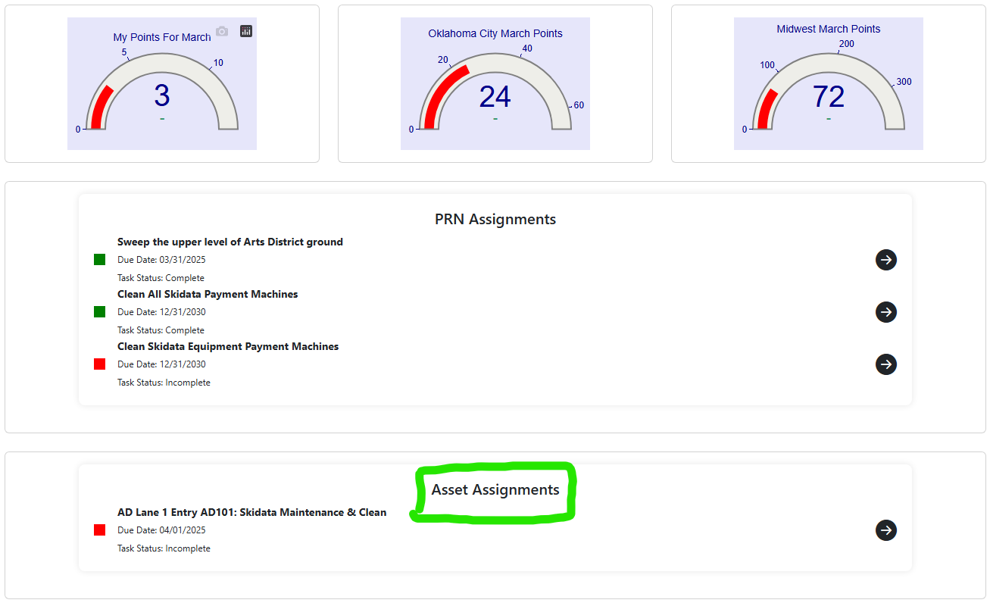

Reporting
To view the number of times the recurring subtask has been marked as Complete in the last 30, 60, 90 and 365 days, visit the Task Snapshot report in the manager menu.
For example, if the manager wants to see how often the wiping down of the Century Center equipment occurred in the last 30 days, they can see the number of records in this report.
  - The manager can also investigate how many times there was an incomplete record of a recurring task in the bottom portion of the report. When a field-user fails to complete (not mark the PRN as complete) in their account, the system will recognize this as an Incomplete record. The manager can use this report to identify PRN’s and/or field-users who are failing to either complete the work or mark their work as complete.
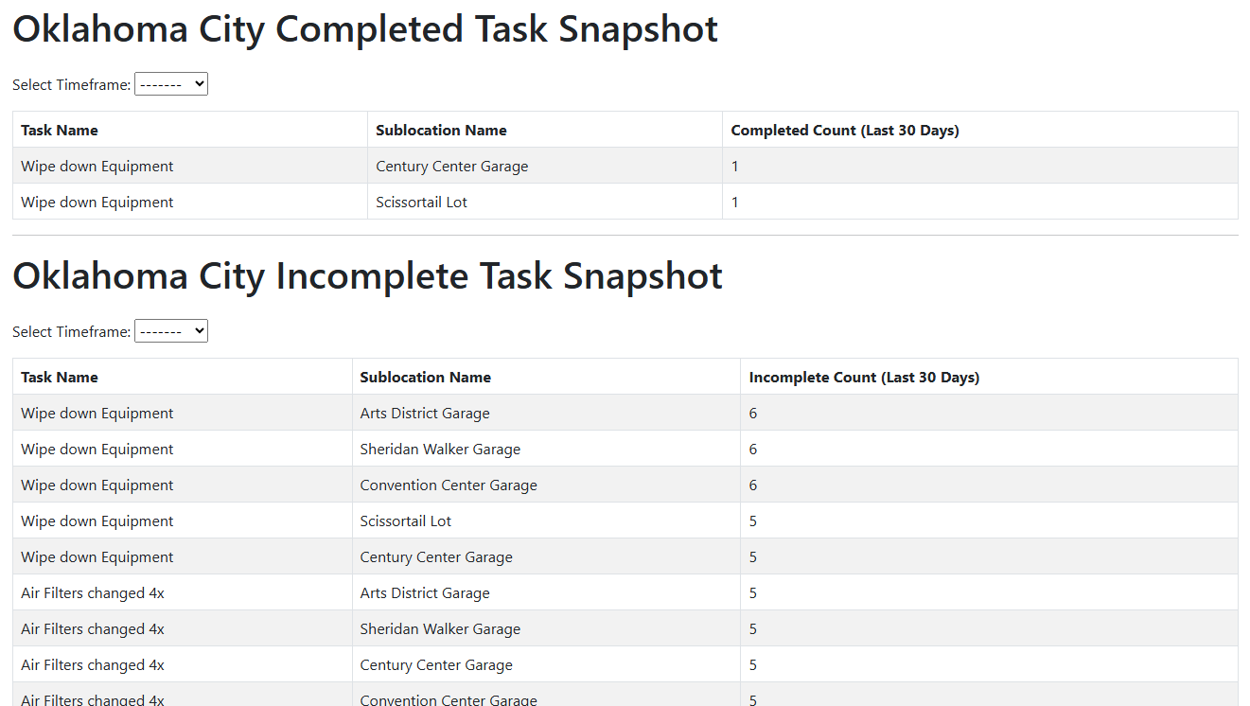

As a manager, you can view the completed PRN in the Task Report page. Simply select the field user from the drop down and select the Completed task status.
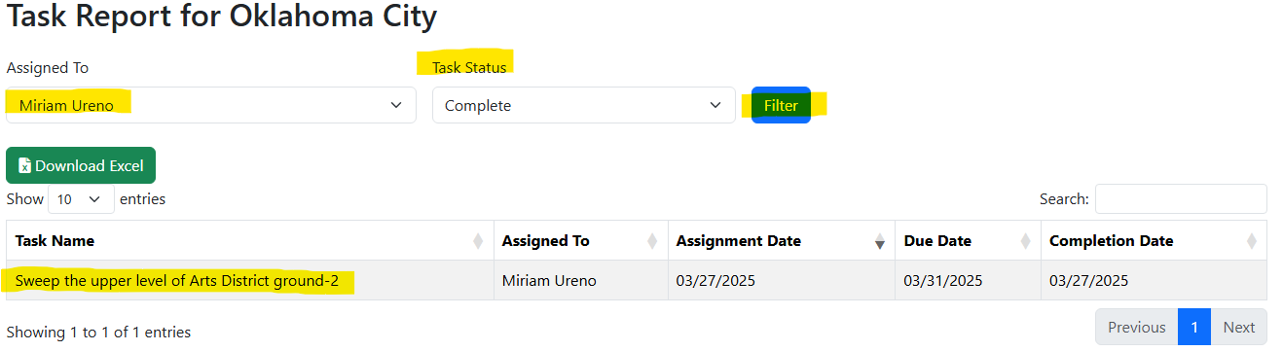
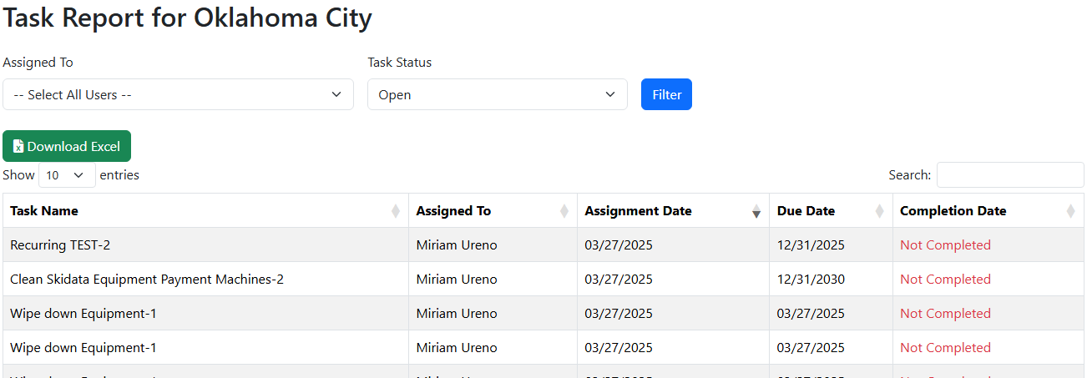
To view a snapshot of the point awarded based on the tasks PRN’s completed, a manger can do so by clicking the Location Scoreboard report from the menu.
